What Is Professional Logo Design and Why Is It Important?
Focus keyword: Professional Logo Design
Meta title: What Is Professional Logo Design and Why Is It Important
Meta description: Learn what professional logo design is and why it’s important for building brand identity, trust, recognition, and long-term business success.
Feature image
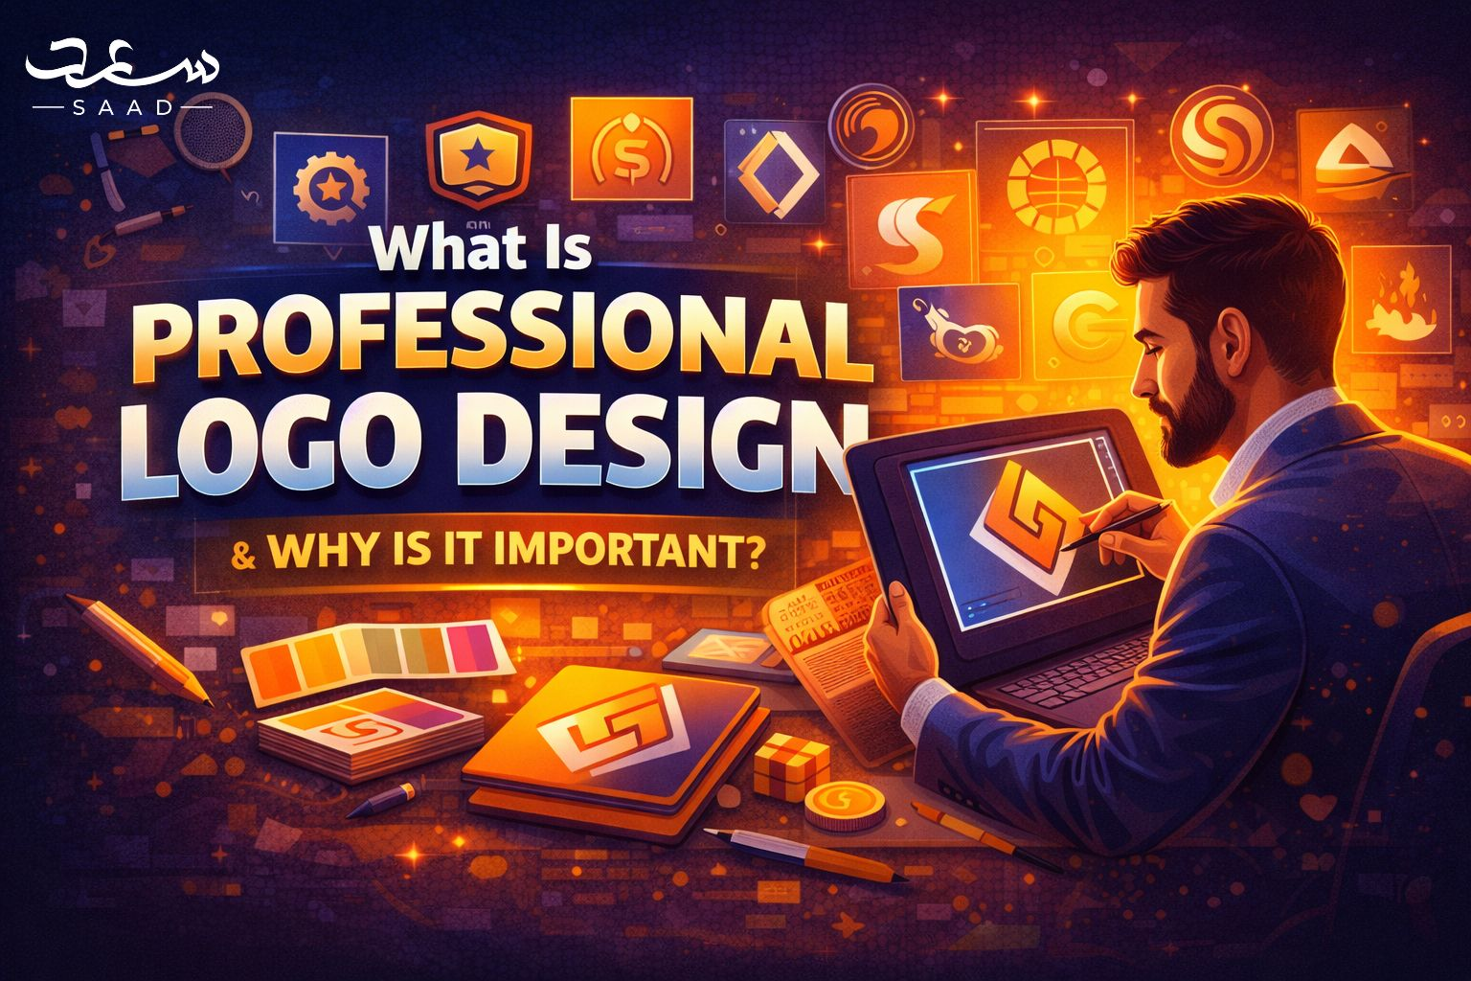
Introduction
A business logo does not just represent a visual logo. It symbolizes values, trust and identity. A good logo develops recognition and credibility at first sight. There is currently intense competition between businesses in both digital and physical markets. First impressions are more important than ever. A professional logo makes a brand come into the limelight. It speaks with intention without uttering a word. Quality is often perceived by customers in terms of visual presentation. An effective logo contributes to branding in the long term. It appeals to the target audience at the emotional level. Bad design kills credibility and brand recognition. Professional design guarantees clarity and consistency all over. This article explains professional logo design and its importance. It also explains why expert design decisions shape business success. Understanding logo value helps brands grow confidently in competitive markets.

Understanding Professional Logo Design
Professional logo design follows strategy, research, and creative thinking. It focuses on brand identity and audience psychology. Designers study business goals before creating visuals. They choose colors, shapes, and fonts carefully. Each element carries meaning and purpose. Professional design avoids random decoration. It ensures scalability across platforms and materials. Logos must work on screens and print equally. A professional approach ensures timeless appeal. It avoids trends that fade quickly. Design consistency builds recognition and trust. Professional logos support long-term brand growth. They align visuals with brand messaging clearly. This structured process separates professional design from amateur work.

Why Logos Matter for Brand Identity
Logos give immediate brand awareness. They depict the values of companies visually. Brands are remembered by customers more quickly in symbols than by words. A powerful logo has an emotional appeal. It assists customers in recognizing familiar businesses with ease. The logos are present in websites, products, and advertisements. Trends create credibility with time. The credibility is enhanced at once with the help of a professional logo. It is an indication of gravity and devotion. Weak logos disorients the audience and undermines perception. Visual consistency is an important element of brand identity.


Role of Research in Logo Creation
Effective logo design is based on research. The designers study the trends in the industry and competitors. They research what the target audience would like to see. Studies determine the emotionally appealing images. It avoids duplication and confusion with the competition. Creative decisions are informed by market knowledge. Colors and symbols should be in line with the cultural meanings. Design risks are minimized through research. It makes sure that logos are effective. The professional designers do not omit research stages. This will be done to make it relevant and original. Studies favor long term brand differentiation. It assists the brands in being distinguished. Good research results in good and effective logos.

Importance of Simplicity in Logo Design
The simplicity provides clarity and remembrance. The simple logos can be identified more easily. They are compatible both in size and platform. Too complicated designs disorient people. Basic logos get old with time. They accommodate their uses readily. Professional designers are concerned with clean images. Strauss enhances brand recognition. It guarantees immediate comprehension. Minimal designs are used by many iconic brands. Simple logos are a sign of confidence and professionalism. They reduce visual noise. Clarity enhances usability through the digital platform. The simplicity is one of the fundamental concepts of good logo design.
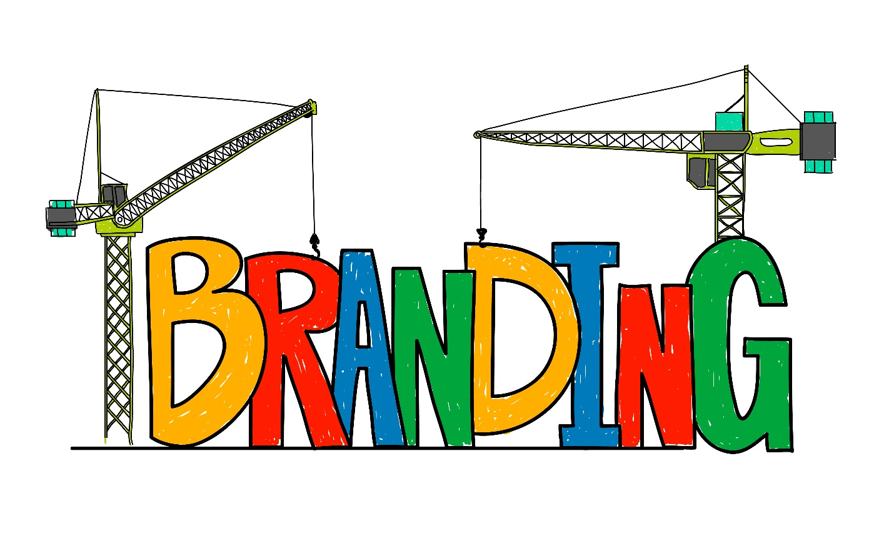

Typography and Its Branding Power
Typography determines brand tone and voice. Fonts convey personality and professionalism. The use of serif fonts implies stability and conservatism. Sans-serif fonts are contemporary and neat. Typography influences perception and legibility. Professional designers choose fonts. Typography must match brand values. Consistent font usage builds recognition. Custom typography adds uniqueness. Text must remain legible everywhere. Typography supports visual harmony. It enhances logo balance and clarity. Strong typography elevates overall brand identity.

Scalability and Versatility of Logos
Logos must perform across all sizes. They should remain clear when scaled down. Versatility ensures usability across platforms. Logos appear on websites and packaging. They must work in colour and monochrome. Professional design ensures adaptability. Poor designs lose clarity when resized. Scalability supports consistent branding. Versatile logos reduce redesign costs. They maintain impact everywhere. Designers test logos in multiple formats. This ensures long-term usability. Versatile logos support marketing flexibility. Strong scalability reflects professional design quality.
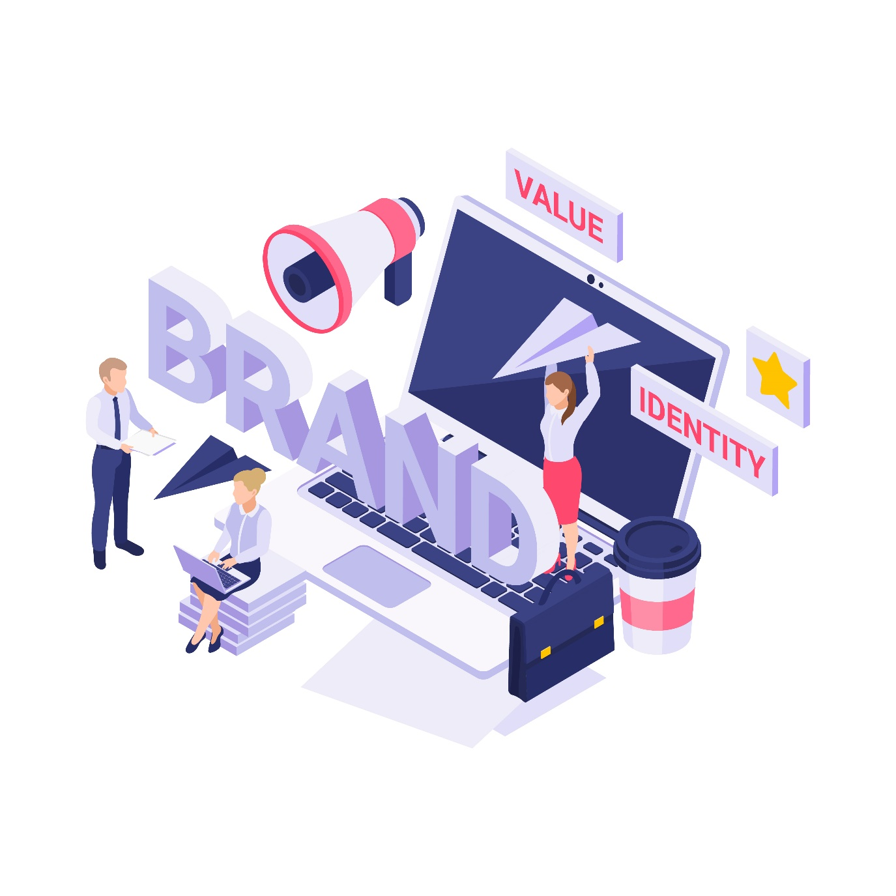

Digital Branding and Logo Importance
Digital platforms demand a strong visual identity. Logos anchor online branding strategies. They appear on websites and social media. Digital audiences expect visual consistency. A professional logo enhances digital trust. It supports online credibility instantly. Logos improve click-through recognition. They help brands stand out online. Poor logos weaken digital presence. Professional design ensures clarity on screens. Digital-first design considers responsiveness. Logos must adapt to various resolutions. Strong digital branding relies heavily on effective logos.

Cultural Relevance in Dubai Markets
Dubai has different international audiences. The issue of cultural sensitivity is relevant in the design decisions. Symbols and colours should not disrespect local values. Local aesthetics are taken into consideration by the professional designers. Relevance is cultural and creates trust with the audience. Incongruent images have the power to offend accidentally. Investigations maintain the right representation. Designers localize international standards. This will enhance acceptance and involvement. Companies that are targeting the area should be culturally aware. Good design strikes a balance between internationalism and localism. Brand credibility grows when there is cultural alignment.

Choosing the Right Design Expertise
Quality results are achieved through professional expertise. Systematic procedures guide skilled designers. They know how to brand and market. Skills minimize expensive errors in design. Professional designers provide strategic value. They correspond visuals to business objectives. The selection of specialists is a time and resource-saving step. The quality design enhances the payback. Competent designers offer innovative solutions. They have experience that makes them original and relevant. Consistency is provided through professional support. Professional advice builds brand bases. Investment in expertise gives long-term returns.

Logo Design as a Long-Term Investment
A logo is a long-term brand asset. It supports marketing efforts consistently. Professional design reduces future redesign costs. Strong logos maintain relevance over time. They adapt to business growth—investment in design yields lasting value. Cheap designs often require replacement. Professional logos support brand stability. They enhance customer trust. A strong logo improves competitive positioning. Long-term branding depends on visual consistency. Logos influence customer perception continuously. Strategic investment ensures sustainable brand success.


Logo Design in Dubai Business Landscape
Businesses often seek logo design in Dubai to compete effectively. The market demands strong visual branding. Companies target diverse global audiences. Professional logos support credibility and trust. Many brands prioritize expert design services. Visual identity influences purchasing decisions. Local competition increases branding importance. Businesses invest in professional visuals. Strategic logos improve market positioning. Quality design reflects business seriousness. Strong logos support growth and recognition. Visual branding plays a crucial role locally. Professional design remains essential for success.

Expert Designers and Market Expectations
Many businesses hire a logo designer in Dubai for expertise. Designers understand market trends deeply. They align visuals with business goals. Professional designers deliver strategic solutions. Their experience ensures originality and quality. Businesses expect clarity and consistency. Designers meet high branding standards. Expertise reduces design risks significantly. Strong collaboration improves outcomes. Designers guide clients effectively. Market expectations demand professional execution. Skilled designers elevate brand perception. Expertise remains crucial for competitive advantage.

Creative Processes in Logo Designing
Creative thinking drives effective logo designing in Dubai. Designers combine strategy and creativity. They brainstorm concepts carefully. Creativity ensures uniqueness and memorability. Structured processes guide creativity effectively. Designers refine ideas through feedback. This approach improves final results. Creativity supports emotional connection. Professional creativity avoids clichés. Designers balance originality with clarity. Creative logos stand out in crowded markets. Strong concepts drive brand recall. Creativity enhances long-term branding success.
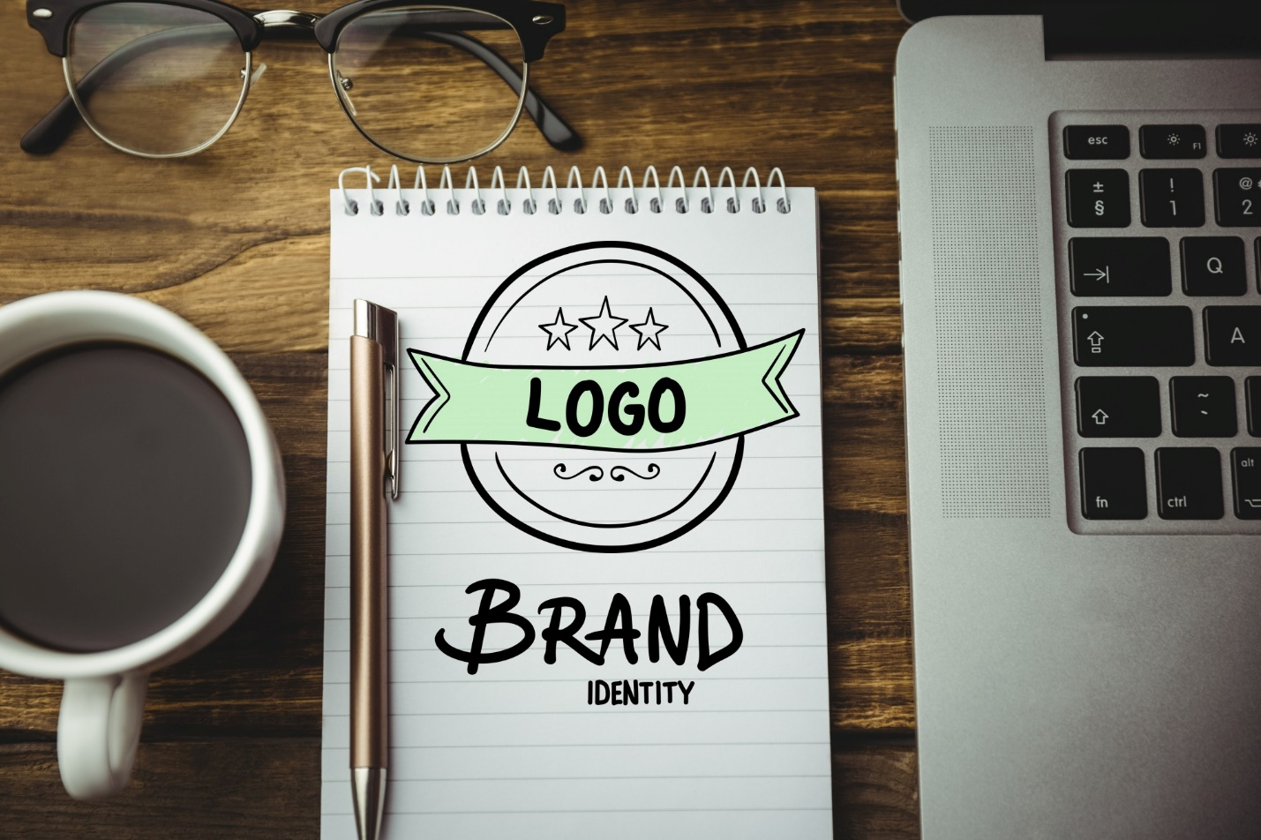

Brand Recognition Through Dubai Logo Design
Strong Dubai logo design improves brand recognition. Visual consistency builds familiarity quickly. Customers identify brands through logos. Effective design supports recall. Logos anchor all branding materials. Professional execution ensures clarity. Recognition increases customer trust. Strong visuals differentiate brands. Logos simplify brand communication. They convey professionalism instantly. Recognition supports marketing effectiveness. Well-designed logos strengthen competitive positioning. Visual identity remains central to branding success.

Professional Standards and Quality Assurance
Businesses often seek professional logo design in Dubai for quality. Professional standards ensure consistency and clarity. Designers follow best practices. Quality assurance prevents design flaws. Professional processes include testing and refinement. This approach ensures usability. Quality logos perform across platforms. Professional standards build trust. Clients expect reliable outcomes. Quality design supports brand credibility. Consistency strengthens brand messaging. Professional execution ensures lasting value. Quality assurance reflects expertise and commitment.

Industry Experience and Reliable Partners
Some brands work with experienced studios like Saaddesign. They value strategic thinking and creativity. Reliable partners understand branding deeply. Experience ensures smooth collaboration. Professional studios deliver consistent quality. They guide clients through design stages. Trusted partners reduce project risks. Experience improves design outcomes. Brands benefit from expert insight. Collaboration enhances creativity and clarity. Reliable partners support long-term branding goals. Experience remains a key success factor.

Conclusion
Professional logo design shapes brand identity and perception. It communicates values clearly and effectively. Businesses benefit from strategic visual branding. A strong logo builds trust and recognition. Professional design ensures consistency and scalability. It supports long-term marketing goals. Quality logos enhance customer confidence. They differentiate brands in competitive markets.

Frequently Asked Questions
What makes a logo professional?
A professional logo follows strategy research and clear design principles.
Why is logo design important for businesses?
Logos create recognition, trust and consistent brand identity.
How long does professional logo design take?
It depends on research revisions and approval stages.
Can a logo affect customer trust?
Yes, strong visuals improve credibility and confidence.
Should logos change with trends?
No timeless design works better than short trends.

